Peter Pan Playgroup
Sun Safety Policy

Procedures

- Outside play takes place every day from 9.30am and children will be encouraged to go outside

- Sun cream should be applied by parents in the morning prior to their child coming into playgroup

- If your child stays all day, please provide a named suncream to keep in their bag for a member of staff to re-apply for the afternoon session.

- Please see chart below (source: Cancer research UK) for guidance on when suncream/sun protection is needed. UV levels for the day can be found on all weather apps.
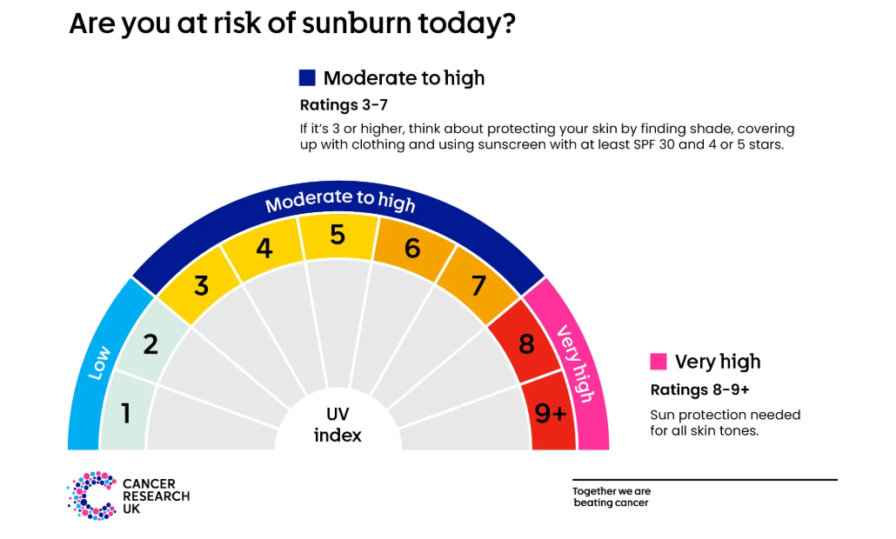

- Parents will need to provide their child's own sun hat which should be clearly labelled with their child's name. Peter Pan Playgroup can provide sun hats if your child does not have one.

- When the sun is strong, we will encourage children to sit/play in the shade where it is available and, if necessary, at any point between 11am and 3pm staff will gauge the weather conditions and, if necessary, will return to the hall.

- Children will have regular access to drinking water in the hall and in hot weather they will have access to drinking water outside to keep them hydrated and cool.

- We ask parents/carers to remember to provide their children with suitable clothing and footwear (wellington boots or ‘Crocs’ clogs – no footwear with laces or buckles please), covering the toes during the summer months to enable children to move freely but safely when outside. Soles need to grip and be secure on the child's foot. NO FLIP FLOPS or similar sandals.

